Using a Michelson Interferometer to Measure and Characterize a HeNe LASER, a Sodium Lamp, and White Light

Department of Physics, Augusta University, Augusta, GA 30912
(Submitted 26 February 2019)
Using a Michelson Interferometer, the approximate equal path length position was located with a HeNe LASER in order to measure the wavelengths of light from the HeNe LASER and a sodium lamp. By counting fringes between two points of the translating mirror, we measured λ_{HeNe} = (665.9 ± 3.5)nm which is 9.35 standard deviations from the known reference value of 632.8nm.¹ We then determined the wavelength spacing between the two sodium light wavelengths by counting washouts as the two wavelengths constructed and deconstructed. When using $\overline{λ}$ we measured Δλ = (0.5970 ± 0.0011)nm which is 0.36 standard deviations from the known spacing of 0.5974nm.² When using λ₁λ₂ we measured Δλ = (0.5972 ± 0.0011)nm which is 0.18 standard deviations away. Lastly, using the approximate equal path length position of the interferometer, we used white light fringes of an incandescent lamp to locate the true equal path length position at (8.011 ± 0.001)mm from the beam splitter.

- INTRODUCTION
The Michelson interferometer was invented by Albert Abraham Michelson and was the centerpiece of the Michelson-Morley experiment in 1887 in an attempt to detect Earth’s motion through the supposed luminiferous aether.³ It has been used extensively in many applications since its invention to measure many things from simple light patterns, such as in this experiment, all the way to detecting gravitational waves as done with the 4 km long LIGO, which is at its essence a giant Michelson interferometer. It typically consists of two mirrors, M₁ and M₂, a beam splitter or half-silvered mirror, sometimes a compensating plate, and a light source. Figure 1 shows the setup used in this experiment.

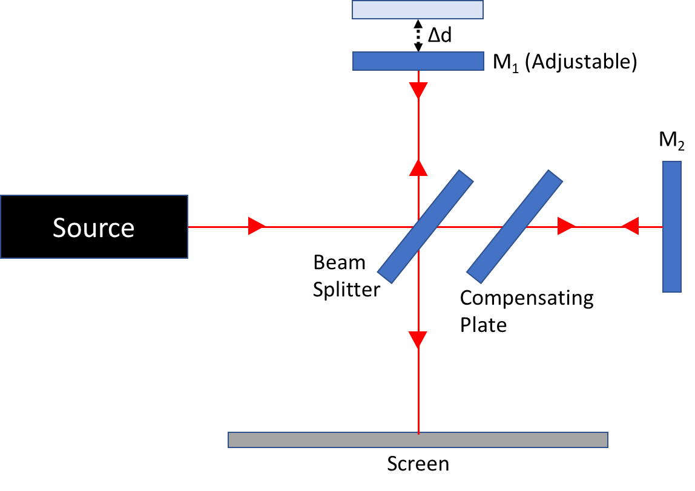
Fig. 1. Illustration of the experiment setup with light source, path of light, and the arrangement of mirrors on the interferometer.

For this experiment, we used a Michelson interferometer with different light sources to measure and determine several different properties and behaviors of these light sources. By using a few mirrors, a beam splitter, and the superposition principle we were able to make precise measurements of intricate properties at the nanometer level.

- PROCEDURE
Our experiment was divided into three tasks, each making use of the Michelson interferometer. Task A had us sending the HeNe LASER light through some free-standing lenses to focus it into the interferometer and using the adjustable mirror to create a fringe pattern on the wall. Our initial goal for Task A required us to use the HeNe LASER to find the approximate equal path length position of the interferometer. As seen in Figure 1, this was done by adjusting the translating mirror until a single bright spot, or “bullseye”, was seen on the wall the light was being reflected on to. This equal path length can be found using Equation (1), where d is the distance from the beam splitter to the translating mirror, m is the number of fringes visible on the screen, and λ is the wavelength of the light.

$2d=mλ$ (1)

Starting some arbitrary distance away from the equal path length position so as to not inadvertently pass through it and reverse the direction of the fringes, we can adjust the mirror and count the number of fringes that pass. The distance the mirror moves becomes Δd and the number of fringes counted becomes Δm. Using (1) and these new values, we derive Equation (2) and can determine the wavelength of the light passing through the interferometer.

$λ=\frac{2(Δd)}{Δm}$ (2)

We recorded at 10-minute video of this method, as seen in Figure 2 below, of slowly but steadily scrolling the fine adjustment knob. Once we felt we had a sufficient number of fringes go by, we ended the video to review and analyze after the experiment to determine the wavelength of the HeNe LASER light. The results are discussed below.
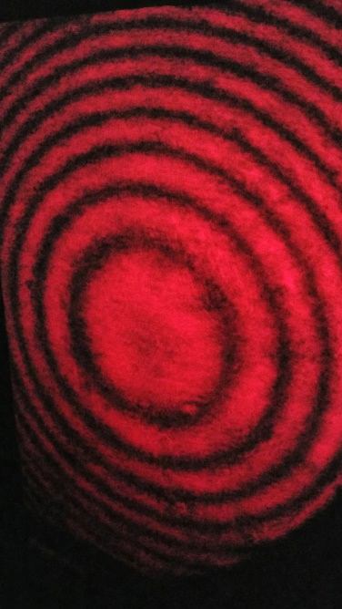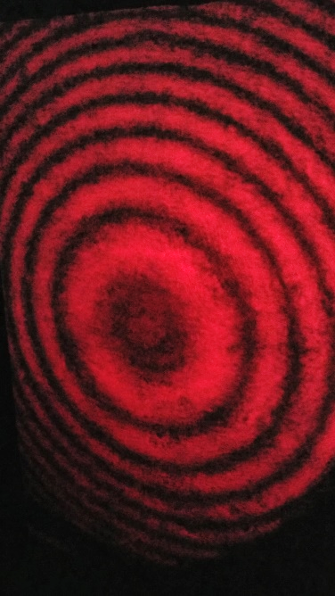
Fig. 2. Sequence of fringes from the HeNe LASER expanding while adjusting the mirror away from the equal path length position. Every time the bullseye produced a new fringe, Δm increased by 1.

For Task B, we used a sodium lamp to view a pattern directly in the interferometer. Since a sodium lamp is too bright to actually view directly, we directed the light at some printer paper taped to a stand and let it reflect into the interferometer. This allowed the safe observation of the sodium light fringes possible, as seen in Figure 3.
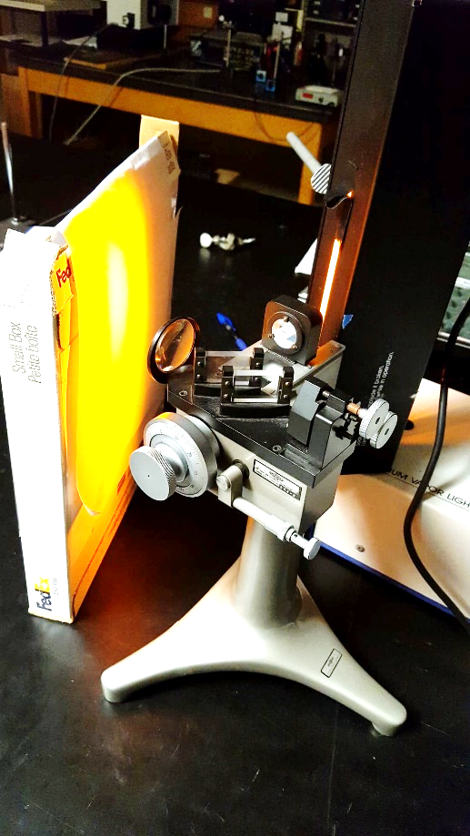
Fig. 3. Sodium lamp light reflecting off a piece of paper into the interferometer. The translating mirror is at the back of the device and is the focal point for viewing for washouts while turning the fine adjustment knob at the lower front right of the device.

Sodium light is actually made up of two closely spaced wavelength lines, 588.9950nm and 589.5924nm in air, with the average wavelength, $\overline{λ}$, being 589.1941nm.² To the naked eye, it obviously will appear as a single color of light, however, with the interferometer, we are able to observe the difference between the two wavelengths and measure the wavelength spacing, Δλ. This spacing appears as a “washout” where multiple fringes are not visible and the viewing area is one single fringe, appearing as a solid-filled view. This occurs when the shorter wavelength is a whole number of wavelengths plus a half wavelength different than the longer wavelength and the bullseye patterns of each wavelength overlap in such a way that the fringes of one wavelength fill the troughs of the other wavelength. As the adjustment knob is turned and d changes until the next washout position is reached, the fringe number, m, for the shorter wavelength has increased by one more than that of the longer wavelength.
Knowing this, we can determine the Δλ of the sodium light by measuring the distance of the translating mirror from the beam splitter at each washout position, d, and the change in fringe count for both wavelengths, Δm, where the subscripts 1 and 2 refer to the longer and shorter wavelengths, respectively. Subscripts A and B are the particular washout at that path difference. Using these wavelength relations to equate Equations (4) and (5), we were able to derive Equations (6.1) and (6.2) to allow us to calculate Δλ as discussed in Results below.

$2d_{A}=m_{1A}λ_{1}=\left(m_{1A}+n+1/2\right)λ_{2}$ (4)

$2d_{B}=m_{1B}λ_{1}=\left(m_{1B}+n+3/2\right)λ_{2}$ (5)

$Δλ=\frac{{(\overline{λ})}^{2}}{2(Δd)}$ (6.1)

or

$Δλ=\frac{λ_{1}λ_{2}}{2(Δd)}$ (6.2)

Our final task, Task C, was to locate the true equal path length position of the interferometer using white light fringes of an incandescent lamp. White light fringes are only visible at the true equal path length position of the interferometer and only occur over an extremely small range of movement of the mirror. Unless this equal path length position is known, finding the white light fringes is literally a shot in the dark and can be missed entirely if translated across too quickly. However, since we located an approximate position during Task A, we knew to start at 7.954mm from the beam splitter and very slowly move the mirror away from that point. We continued until we observed the white light begin to separate into bands of colors and stopped when they seemed the most distinct.

- RESULTS
For Task A, using (1) we determined the approximate equal path length position to be when the mirror is located (7.954 ± 0.001)mm from the beam splitter. This was based on visually locating what appeared to be a single, large fringe cover the whole viewing area. Based on this being a visual determination, we knew the position we had measured was only an approximate location of the equal path length.
From the 10-minute video we took of the fringes expanding while moving the mirror, starting with the mirror at (7.400 ± 0.001)mm, we counted (883 ± 2) fringes went by with the mirror being stopped at (7.106 ± 0.001)mm for a change of (0.294 ± 0.001)mm. We slowed the video down to 25% normal speed to ensure we counted the fringes as accurately as possible. However, the fine adjustment knob on the interferometer has some play in it and continues to move slightly even after turning has stopped and the knob has been let go of. We took extra care to only turn the adjustment knob in one direction so as to keep the uncertainty of the distance traversed to a minimum. We estimate this extra play to be a movement of ±0.001mm of the mirror which in turn accounts for a few more fringes after manual turning of the knob ceased. However, the video does not show the hand on the adjustment knob and thus, we don’t know exactly when it was removed, only that it was just before the last fringes went by which we estimate was no more than ±2 fringes.
Using (2), the readings made from the interferometer, and the fringe count from the video we determined λ_{HeNe} = (665.9 ± 3.5)nm. This is 9.35 standard deviations from the reference value of 632.8nm for the wavelength of light of the HeNe LASER.¹ This large deviation from the known value is most likely due to the systematic uncertainty in the adjustment knob of the interferometer. We counted the fringes as accurately as possible and thus the uncertainty from it is almost negligible.

Task B asked us to determine the wavelength spacing, Δλ, of the sodium light lines. To do this we first plotted the position of each washout as a function of the washout number, n, and used a linear fit to estimate the average change of position, Δd, per washout. However, if we simply plotted the read value of each position, the slope would be negative. So instead, we plotted the change in position relative to the position of the first washout. This produces the same slope value and uncertainty when using a linear fit as it does when the absolute position is plotted but the slope is positive. All of these values are listed in Table 1 shown in Figure 4 below with the plot of these values shown in Figure 5 following.
From the plot, using a linear fit we calculated the average Δd per washout to be (0.2908 ± 0.0005)mm. Our ability to consistently find the center of each washout position ensured a small uncertainty which in turn allowed us to calculate a more accurate Δλ. Now that we had Δd, we only had to decide which equation to use. The difference between (6.1) and (6.2) is the use of $\overline{λ}$ and λ₁λ₂. If we derived (4) and (5) all the way out it actually becomes (6.2). However, (6.1) can be used as a very good approximation if only $\overline{λ}$ were known at the start of the experiment since $\overline{λ}$² is very close to λ₁λ₂. It’s only a 0.034% difference. For the sake of this experiment, we used both (6.1) and (6.2) in order to compare their results. First, using $\overline{λ}$² with (6.1) yields Δλ = (0.5970 ± 0.0011)nm which is 0.36 standard deviations from the known wavelength spacing of 0.5974nm. Following, using λ₁λ₂ with (6.2) we more accurately determined Δλ = (0.5972 ± 0.0011)nm which is only 0.18 standard deviations away, or half as far from the known value when the average wavelength is used. However, both calculations are well within one standard deviation and can be consider in agreement with the known value of 0.5974nm. The uncertainty in our measurements solely comes from Δd due to visually noting when a washout position has been reached and accounting for the play in the adjustment knob.
Fig. 4. Measurements of washout positions, the relative difference of each position to the first washout, and the differences between each position from the previous one.
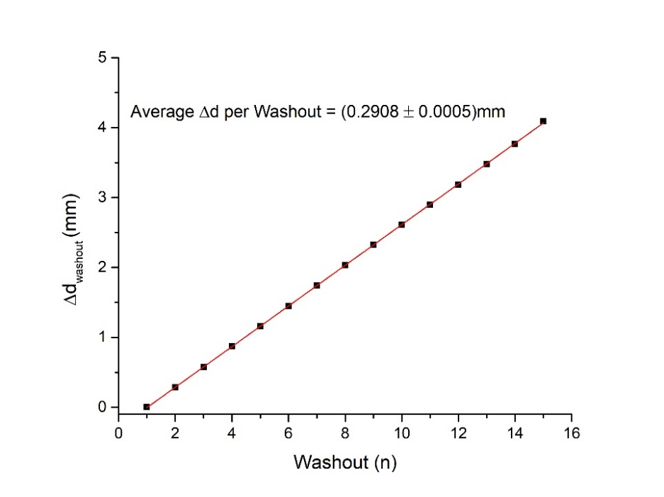
Fig. 5. Plot of the data from Table 1 with a linear fit calculating the average Δd per washout to be used in (6.1) or (6.2) to determine the Δλ.
Task C had us locating the true equal path length position using white light fringes. White light is made up of all the wavelengths of visible light, which means it has all the visible colors in it and these fringes of color are the visible separation of these wavelengths as they travel through the beam splitter. Using these white light fringes, we located the true equal path length position of the interferometer when the mirror was (8.011 ± 0.001)mm from the beam splitter. These white light fringes can be seen below in Figure 6 as the various color wavelengths separate and form distinct bands instead of a solid white image.
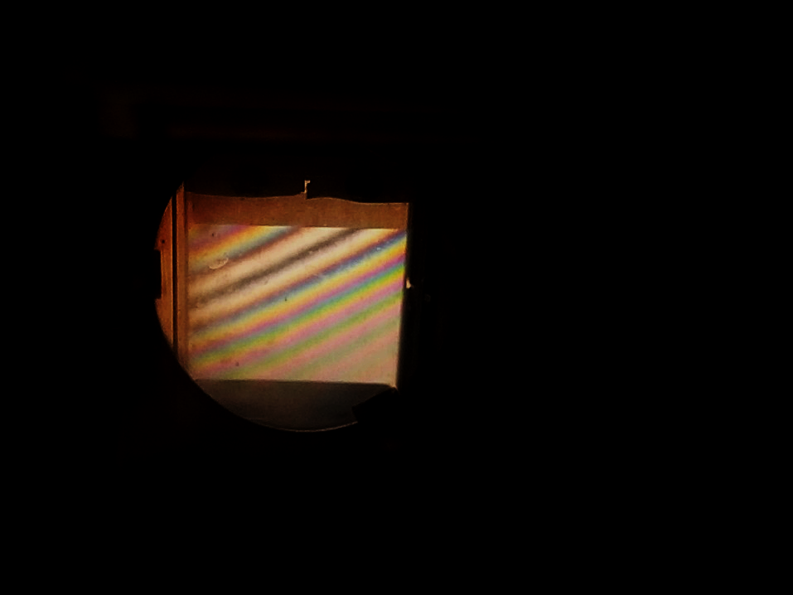
Fig. 6. White light fringes visible in the adjustable mirror of the interferometer. The distinct bands of color are only visible at or near the equal path length of the device.

Going beyond the tasks of the experiment, we measured the index of refraction of air. To do this we used a vacuum chamber of length (4.45 ± 0.01)cm and a vacuum pump to compare the behavior of LASER light in air and in a vacuum. We created a setup similar to that in Task A by shining the LASER light through the vacuum chamber and interferometer creating a fringe pattern on the wall. We then put the chamber under vacuum and the gauge read a final pressure change of (23.5 ± 0.1)inHg. We then slowly released the vacuum, letting air return to into the chamber until the room pressure of 30inHg was reached. By doing this, we observed the fringes of the LASER light on the wall slowly changing. By counting this fringe change, we were able to calculate the index of refraction of air. Air is composed of various gases and has a density. When light from a point source such as a LASER is shined through it, most of the light continues forward without interacting with any molecules. However, some light still does interact with the air molecules and is slowed down by these interactions. By creating a vacuum in the chamber, we removed as many of these air molecules as possible to minimize the refraction occurrences, thus changing the index of refraction. Most gases, including air, have an index of refraction close to 1, whereas air in a vacuum has an index of 1. The index change of air is proportional the pressure change. The index is known as n and the change in the index is Δn, which can be measure using
$∆n=\frac{λ}{2L}$ (7)
where 2L is twice the chamber length due to the light traveling through it twice. As the pressure changes in the chamber, the fringes shift by 1 each time Δn changes by a certain amount. Therefore, the fringe count, m, is added to (7) to become

$∆n=\frac{mλ}{2L}$ (8)
and p is the final pressure of the chamber, which is the room pressure, and Δp is the change in pressure. Since n is proportional to pressure, after some rearranging and simplifying, we get our final equation to calculate the index of refraction of a gas, and in this case, air.

$n=1+\frac{mλP}{2LΔP}$ (9)

We performed three trials of evacuating and refilling the chamber while filming the fringe pattern. The average fringe count from those trials was 24.67 fringes, counted at 25% speed to ensure no fringes were missed. Using the known reference value of the LASER for the wavelength, the measured values above, and (9) we determined the index of refraction of air to be (1.00022 ± 0.00481). The large uncertainty comes from the pressure gauge only having major marks and having to estimate where the true value being read is at. The reference value for the index of refraction of air at STP (20°C, 30inHg) is 1.000271800.⁴ Our result is within a reasonable range of the reference value but with such a large systematic uncertainty, it is hard to tell exactly how close or far off it is.

- Conclusion
For this experiment we used a Michelson interferometer to grossly locate its equal path condition using a HeNe LASER. From there we used the changing fringe pattern to calculate the wavelength of the LASER light. We then observed a sodium lamp and measured the distance between washouts of the two sodium light wavelengths as we adjusted the mirror. We used this distance to determine the spacing between the sodium light wavelengths. Following that, we then used the white light of a lamp and starting at the approximated equal path length position, we located the true equal path length position of the interferometer. Lastly, we used a vacuum chamber to measure the index of refraction of air by evacuating the chamber and then refilling it and measuring the fringe change.
All of these tasks were made possible by the Michelson interferometer. They illustrated the precise nature of the device and demonstrated its ability to be used to measure something down to the nanometer scale. This showed how such a small, seemingly simple device can have far-reaching effects and uses such as precision manufacturing, the measuring of constants and physical properties, and the observation of the behavior of light. All are extremely useful and important things that were made possible by Michelson’s invention, despite its first major use disproving what it had set out to prove.

- References
¹ JDSU 1135/P HeNe LASER datasheet. https://www.lumentum.com/en/products/LASER-head-helium-neon-1100-series. Web. Feb 2019.

² Persistent Lines of Neutral Sodium (Na I). NIST. https://physics.nist.gov/PhysRefData/Handbook/Tables/sodiumtable3.htm. Web. Feb 2019.

³Michelson interferometer. Wikipedia. https://en.wikipedia.org/wiki/Michelson_interferometer. Web. Feb 2019.

⁴Index of Refraction of Air. Stone, Jack A.; Zimmerman, Jay H. NIST. https://emtoolbox.nist.gov/Wavelength/Documentation.asp. Web. Feb 2019.

